PAPER TITLE, FONT TYPE-Times New Roman 14
First Author¹, Second Author², Third Author³ (Font-Times New Roman, Bold, Font Size -12)
¹Designation, Department, Institute, City, State, Country (Font Size -11)
²Designation, Department, Institute, City, State, Country
³Designation, Department, Institute, City, State, Country
ABSTRACT (Font-Times New Roman, Bold, Font Size -12)
An abstract is a summary of entire paper should be written in Times new roman with font size- 10. The abstract should not be more than 200 words and written in single paragraph. This electronic document is a “live” template. The abstract includes the overall purpose of the study you investigated, the basic design of the study, results of your analysis and brief summary of your interpretations and conclusion
Keywords: Analysis, investigation, research (5-6 Keywords, Font-Times New Roman, Font Size – 10).
- INTRODUCTION (Font-Times New Roman, Bold, Font Size -12)
The introduction should be typed in Times New with font size 10. In this section highlight the importance of topic, making general statements about the topic and Presenting an overview on current research on the subject. The simplest way is to replace(copy-paste) the content with your own material. Your introduction should clearly identify the subject area of interest.
- METHODOLOGY
Method and analysis which is performed in your research work should be written in this section. A simple strategy to follow is to use keywords from your title in first few sentences.
2.1 Subheading
Subheading should be Font Size- 10pt, Font Type- Times New Roman, justified.
2.2 Subheading
Subheading should be 10pt Times new Roman,
- MODELING AND ANALYSIS
Fluid and Material which are used is presented in this section. Table and Fluid should be in prescribed format.
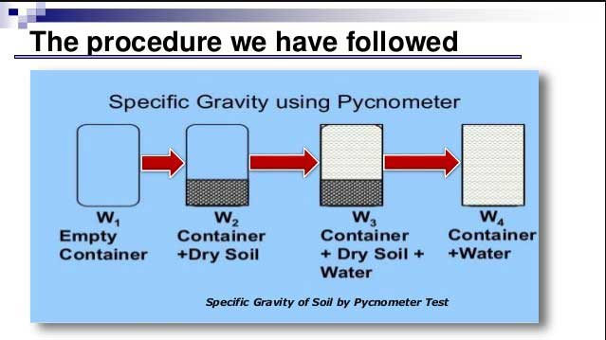
Figure 1: Pycnometer Test Procedure.

- RESULTS AND DISCUSSION
In this Section results and discussion of the study is written. They may also be broken into subsets with short, revealing captions. This section should be typed in character size 10pt Times New Roman.

Table 1. Sample Comparison
SN. | Sample | Quantity (Liter)
1 | Fluid A | 22
2 | Fluid-B | 15
3 | Fluid-C | 12
4 | Fluid-D | 10
5 | Fluid-E | 27
6 | Fluid-F | 32

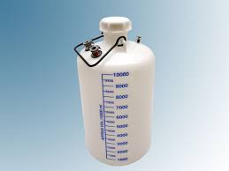
Figure 2: 10 liter capacity vessel (Font size-10)
Unless or otherwise specified specific gravity values reported shall be based on water at 270C. So the specific gravity at 27⁰C = K Sp. gravity at Tx⁰C. The specific gravity of the soil particles lie with in the range of 2.65 to 2.85. Soils containing organic matter and porous particles may have specific gravity values below 2.0. Soils having heavy substances may have values above 3.0.
- CONCLUSION
All the main points of the research work are written in this section. Ensure that abstract and conclusion should not same. Graph and tables should not use in conclusion.
ACKNOWLEDGEMENTS (optional)
The authors can acknowledge professor, friend or family member who help in research work in this section.
- REFERENCES
- T. Mohana Priya, Dr. M. Punithavalli & Dr. R. Rajesh Kanna, Machine Learning Algorithm for Development of Enhanced Support Vector Machine Technique to Predict Stress, Global Journal of Computer Science and Technology: C Software & Data Engineering, Volume 20, Issue 2, No. 2020, pp 12-20
- Ganesh Kumar and P.Vasanth Sena, “Novel Artificial Neural Networks and Logistic Approach for Detecting Credit Card Deceit,” International Journal of Computer Science and Network Security, Vol. 15, issue 9, Sep. 2015, pp. 222-234
- Gyusoo Kim and Seulgi Lee, “2014 Payment Research”, Bank of Korea, Vol. 2015, No. 1, Jan. 2015.
- Chengwei Liu, Yixiang Chan, Syed Hasnain Alam Kazmi, Hao Fu, “Financial Fraud Detection Fluid: Based on Random Forest,” International Journal of Economics and Finance, Vol. 7, Issue. 7, pp. 178-188, 2015.
- Hitesh D. Bambhava, Prof. Jayeshkumar Pitroda, Prof. Jaydev J. Bhavsar (2013), “A Comparative Study on Bamboo Scaffolding And Metal Scaffolding in Construction Industry Using Statistical Methods”, International Journal of Engineering Trends and Technology (IJETT) – Volume 4, Issue 6, June 2013, Pg.2330-2337.

